**MERN stack vs. MEAN stack:What’s the Difference and Which One to Choose?**

First of all we have to understand what are MERN and MEAN stack :-

**MERN stack :-** MERN Stack is a compilation of four different technologies that work together to develop dynamic web apps and websites.

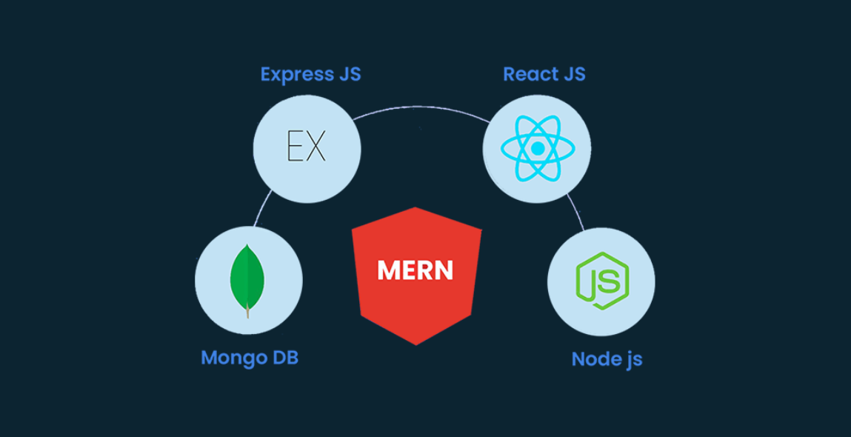

1. MongoDB

MongoDB is a NoSQL [DBMS](https://www.simplilearn.com/dbms-interview-questions-and-answers-article) where data is stored in the form of documents having key-value pairs similar to JSON objects. MongoDB enables users to create databases, schemas, and tables. It offers the Mongo shell that provides a JS interface for deleting, querying, and updating the records.

1. ExpressJS

ExpressJS is a NodeJS framework that simplifies writing the backend code. It saves you from creating multiple Node modules. For keeping the code precise, ExpressJS offers a range of middleware.

1. ReactJS

ReactJS is a JS library that allows the development of user interfaces for mobile apps and SPAs. It allows you to code JavaScript and develop UI components. The JS library uses virtual DOM for doing everything.

1. NodeJS

NodeJS is an open-source JavaScript runtime environment that allows users to run code on the server. It comes with the node package manager or npm, enabling users to select from a wide selection of node modules or packages. Being developed on the Chrome JavaScript Engine enables Node to execute code faster.

**MEAN stack : -**

MEAN stack is an acronym for a technology stack that uses popular web application development tools and technologies namely MongoDB, Express.js, Angularjs (or Angular), and Node.js.

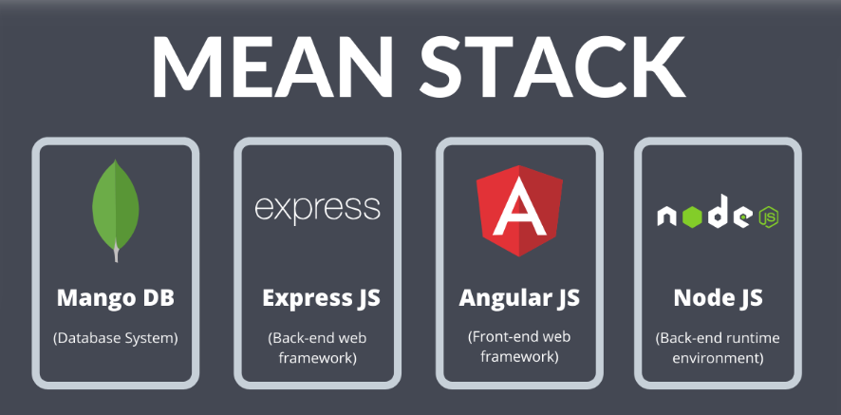

1. MongoDB

MongDB is a popular database server that stores data structures in a binary JSON format. It’s categorised as a NoSQL database program that helps in working with large-scale data sets very efficiently.

1. Express.js

Express.js is a minimal open-source backend web application development framework. Its flexibility makes back end development much easier for developers.

1. AngularJS or Angular

Mainly used to build single-page web applications,Angular.JS is a robust open-source front end framework based on javascript. Many developers also prefer to use Angular 2+ versions that are simply called Angular.

1. Node.js

Node.js is an open-source, cross-platform runtime JavaScript environment. It’s a great platform for developing high performing and scalable server-side applications.

**MEAN stack vs. MERN stack**

| MEAN Stack | MERN Stack |
| --- | --- |
| MEAN uses the AngularJS framework | MERN uses the ReactJS library |
| MEAN is backed by Google Inc. | MERN is backed by Facebook Inc. |
| It exhibits a steeper learning curve | It is much simpler to learn |
| Angular.js has undergone major alterations from version 1 to version 2 | React.js performs better than Angular.js in maintaining UI rendering |
| MEAN maintains abstraction in coding and also manages files | MERN develops code at a quicker rate |
| MEAN Stack is preferable at the enterprise-level architecture | MERN is preferred for the quick development of smaller applications |
| It possesses ready-to-use features to support multiple third-party libraries | React.js requires additional libraries to support such calls |
| It offers better developer productivity | React offers lower developer productivity |
| Data flow is bidirectional, i.e., when the UI is changed, the model state is automatically changed | Data flow is unidirectional, i.e., the UI can be changed only after changing the model state |
| MEAN is suitable for handling small projects | MERN is more suitable for managing larger projects |

**WHICH ONE TO CHOOSE?**

The major difference between MEAN Stack and MERN Stack is that the React and Angular Frameworks have similar benefits and drawbacks. Angular is backed by Google Inc. and React JS by Facebook Inc.., the leading players in the industry. Thus deciding which one to choose is challenging.

### 

### **CRUCIAL FACTORS TO CHOOSE :-**

### 1. MAINTENANCE AND IMPROVEMENT

Entrepreneurs prefer to hire react developers over Angular developers when choosing between the two top frameworks. Thus, consider employing the MERN Stack if you have a large modification pipeline for your app and long-term maintenance needs. For eCommerce projects, the MEAN Stack is an ideal choice.

### 2. UI REQUIREMENTS

MERN is your go-to framework for sophisticated yet easy UI rendering for your application. It can quickly create and display a screen frame for smooth user interaction.

### 3. THIRD-PARTY SUPPORT

Another thing to consider while working on enterprise-level apps is that you can easily use third-party libraries. MEAN uses AngularJS, which provides built-in functionality for making http calls and connecting to the backend. ReactJS, on the other hand, comes with additional libraries that do the same functions. Third-party extensions are handled by MEAN in a plug-and-play fashion, whereas MERN requires additional setups.

### 4. SECURITY AND SCALABILITY

Both the MERN and MEAN stacks offer best-in-class security. Thus, you can choose any of them. However, MERN wins the game in terms of security because it is more scalable than MEAN.

### 5. NICHE PROJECTS

The MERN Stack allows you to create and deploy a CRUD application from start to finish. React allows efficient handling of quickly changing data while providing an impressive user interface. It'd be better to use MERN for a small project like a single-page application or a mobile app.

## **So At Last I want to say that** the close-knit competition between the MEAN and MERN stacks makes it a challenging task to choose one of them. Both technologies have reliable frameworks, best-in-class functionality, and capabilities. However, the major difference is their structure, making MEAN a better option for large-scale apps, and MERN is ideal for smaller apps. Thus, it is best to choose the MEAN VS MERN stack as per your company's needs to create a dynamic app.